**Experiment 6**

**Aim:** Program to demonstrate CRUD (create, read, update and delete) operations on database (SQLite/ MySQL) using python.

**THEORY:**

**Q.** Explain need of database.

**Ans:** A database is a collection of data, usually stored in electronic form. A database is typically designed so that it is easy to store and access information. A good database is crucial to any company or organization. This is because the database stores all the pertinent details about the company such as employee records, transactional records, salary details etc.

The various reasons a database is important are –

1. Manages large amounts of data -

A database stores and manages a large amount of data on a daily basis. This would not be possible using any other tool such as a spreadsheet as they would simply not work.

1. Accurate-

A database is pretty accurate as it has all sorts of build in constraints, checks etc. This means that the information available in a database is guaranteed to be correct in most cases.

1. Easy to update data-

In a database, it is easy to update data using various Data Manipulation languages (DML) available. One of these languages is SQL.

1. Security of data-

Databases have various methods to ensure security of data. There are user logins required before accessing a database and various access specifiers. These allow only authorized users to access the database.

1. Data integrity-

This is ensured in databases by using various constraints for data. Data integrity in databases makes sure that the data is accurate and consistent in a database.

1. Easy to research data-

It is very easy to access and research data in a database. This is done using Data Query Languages (DQL) which allow searching of any data in the database and performing computations on it.

**Q.** Explain how python is connected to MySQL

**Ans:** Installing pymysql

1. We first install pymysql by using command -pip install pymysql
2. Import the pymysql. Then we import the pymysql module into our python file with the command import pymysql. Create the connection object.
3. We then create the connection object with the follow command i.e. connection=pymysql.connect(host="localhost",user="root",db="experiment")
4. Create the cursor object. Thereafter we create the cursor object using the command i.e. cur=connection.cursor()
5. Execute the query. Then we execute the query we want like CRUD operations

### IMPLEMENTATION:

### Create table for Employee database having fields empno(pk), EmpName, Salary, Date of Joining using Python

**Code:**

import pymysql

connection=pymysql.connect(

host="localhost",

user="root",

db="experiment"

)

cur=connection.cursor()

s='''create table Employee(

empno integer primary key,

EmpName varchar(20),

Salary integer,

DOJ varchar(20)

)'''

cur.execute(s)

connection.close()

**Output:**

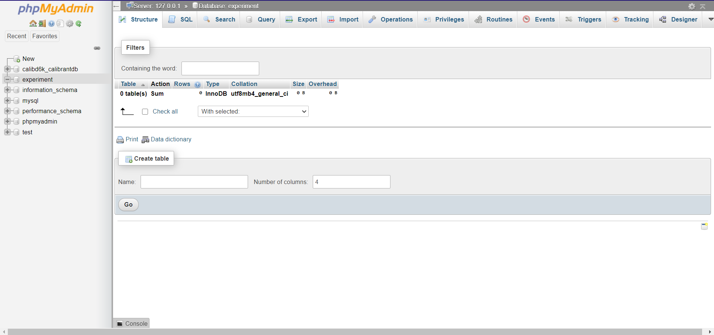

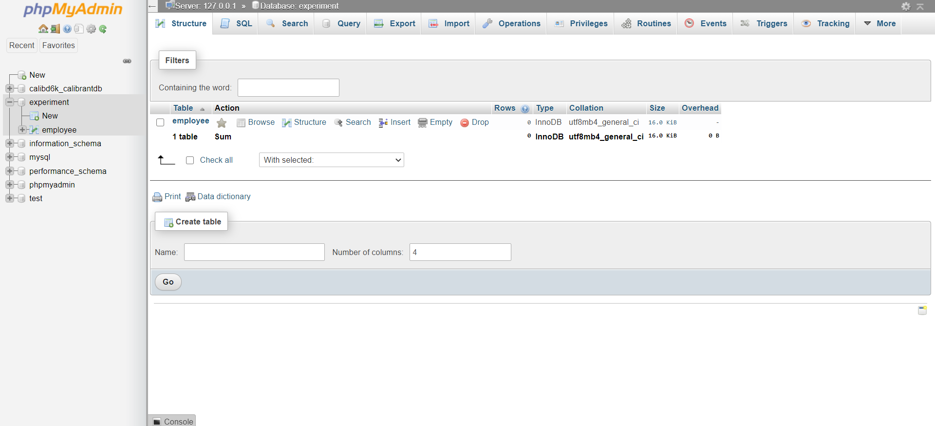

### Implement functions read, update, insert and delete on this table.

### Accept input for these operations from user through widgets.

**Code:**

**Insert:**

import pymysql

from tkinter import *

def add(event):

connection=pymysql.connect(

host="localhost",

user="root",

db="experiment"

)

cur=connection.cursor()

r=int(ro.get())

n=nm.get()

sal=int(sa.get())

date=da.get()

s="insert into employee(empno, EmpName, Salary, DOJ) values ('%d','%s','%d','%s')"

args=(r,n,sal,date)

try:

cur.execute(s%args)

print("added")

except:

print("something went wrong")

connection.commit()

connection.close()

window=Tk()

window.geometry("500x500")

lbl=Label(window, text="empno")

lbl.place(x=60,y=50)

ro=Entry(window)

ro.place(x=180,y=50)

lb2=Label(window, text="EmpName")

lb2.place(x=60,y=80)

nm=Entry(window)

nm.place(x=180,y=80)

lb3=Label(window, text="Salary")

lb3.place(x=60,y=110)

sa=Entry(window)

sa.place(x=180,y=110)

lb4=Label(window, text="DOJ")

lb4.place(x=60,y=140)

da=Entry(window)

da.place(x=180,y=140)

btn=Button(window, text="add record")

btn.place(x=200,y=160)

btn.bind('<Button-1>',add)

**Update:**

import pymysql

from tkinter import *

def upname(event):

connection=pymysql.connect(

host="localhost",

user="root",

db="experiment"

)

cur=connection.cursor()

r=int(ro.get())

n=nm.get()

s="update employee set EmpName='%s' where empno='%d'"

args=(n,r)

try:

cur.execute(s%args)

print("updated name")

except:

print("something went wrong")

connection.commit()

connection.close()

def upsal(event):

connection=pymysql.connect(

host="localhost",

user="root",

db="experiment"

)

cur=connection.cursor()

r=int(ro.get())

sal=int(sa.get())

s="update employee set Salary='%d' where empno='%d'"

args=(sal,r)

try:

cur.execute(s%args)

print("updated salary")

except:

print("something went wrong")

connection.commit()

connection.close()

window=Tk()

window.geometry("500x500")

lbl=Label(window, text="empno")

lbl.place(x=60,y=50)

ro=Entry(window)

ro.place(x=180,y=50)

lb2=Label(window, text="EmpName")

lb2.place(x=60,y=80)

nm=Entry(window)

nm.place(x=180,y=80)

lb3=Label(window, text="Salary")

lb3.place(x=60,y=110)

sa=Entry(window)

sa.place(x=180,y=110)

btn=Button(window, text="update name")

btn.place(x=200,y=160)

btn.bind('<Button-1>',upname)

btn=Button(window, text="update salary")

btn.place(x=200,y=200)

btn.bind('<Button-1>',upsal)

**Read and Delete:**

import pymysql

from tkinter import *

def read(event):

connection=pymysql.connect(

host="localhost",

user="root",

db="experiment"

)

cur=connection.cursor()

r=int(ro.get())

s="select * from employee where empno='%d'"

args=(r)

cur.execute(s%args)

results = cur.fetchall()

for i in results:

print(i)

connection.commit()

connection.close()

def delete(event):

connection=pymysql.connect(

host="localhost",

user="root",

db="experiment"

)

cur=connection.cursor()

r=int(ro.get())

s="delete from employee where empno='%d'"

args=(r)

try:

cur.execute(s%args)

print("delete")

except:

print("something went wrong")

connection.commit()

connection.close()

window=Tk()

window.geometry("500x500")

lbl=Label(window, text="empno")

lbl.place(x=60,y=50)

ro=Entry(window)

ro.place(x=180,y=50)

btn=Button(window, text="read")

btn.place(x=200,y=160)

btn.bind('<Button-1>',read)

btn=Button(window, text="delete")

btn.place(x=200,y=200)

btn.bind('<Button-1>',delete)

**Output:**

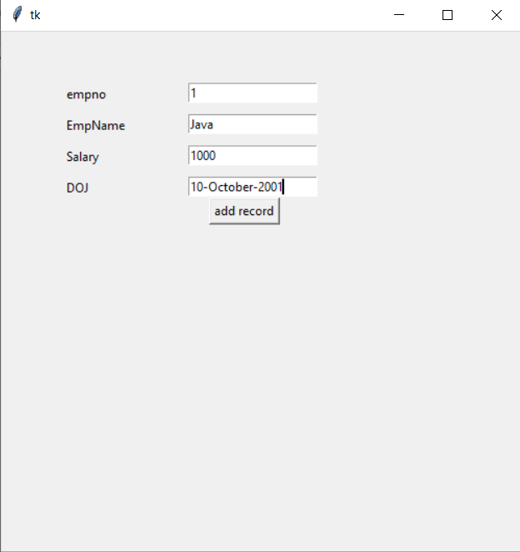 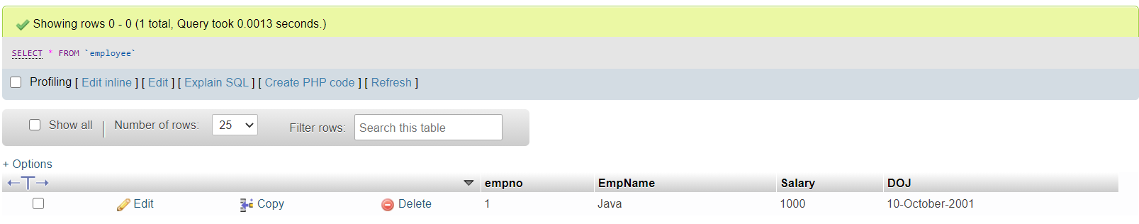

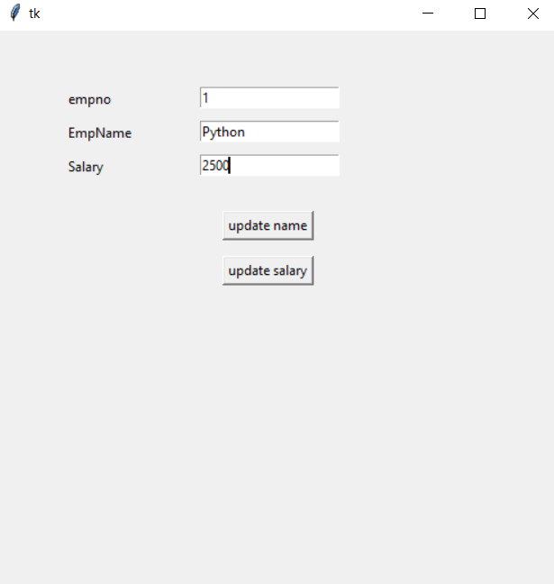 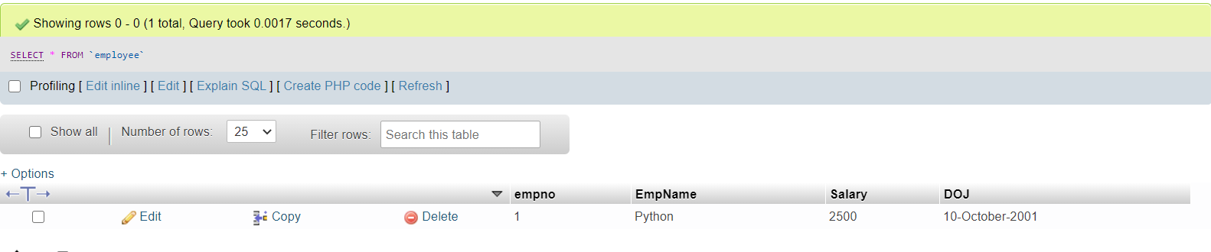 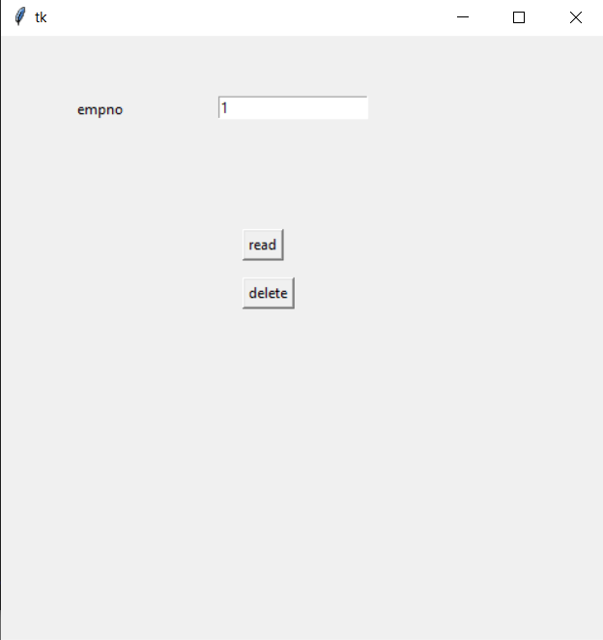 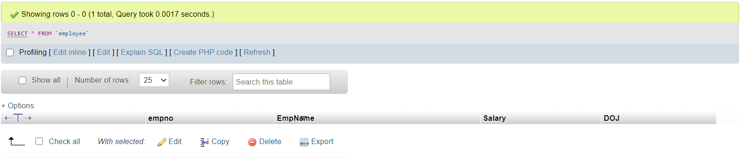

### Conclusion:

Successfully learnt how to use CRUD operations in Python also learnt how to connect python to mysql.